Assignment 5.2: Predictive Analytics Case Study
Credit Default Prediction Using Time Series-Based Machine Learning
Introduction

Credit card defaults are the failure to make minimum payments on credit card debt. While spending patterns may vary among individuals, widespread defaults could be indicative of a more significant underlying issue. In essence, credit card companies must incorporate risk into their business models to ensure their continued operations. Traditional scoring systems, such as FICO, have served their purpose for a certain period. However, the advent of big data, machine learning, and artificial intelligence offers avenues for identifying “more complex, non-linear patterns” within the data.
Credit card defaults primarily affect credit card distributors. However, widespread defaults can lead to recessions or depression. Credit acts as an accelerator for poor financial decisions. The decision to issue a credit card involves the risk that the borrower will repay the borrowed amount. FICO holds a renowned status among financial institutions. Credit ratings, such as “AAA” or “A+,” may be acceptable for public discussion, but the true credit rating can be achieved through more intricate mathematical and modeling techniques. Given that previous risk aversion strategies have failed to anticipate crises, machine learning must be employed in conjunction with the extensive credit data to predict credit card defaults before they occur.

The study utilized a dataset spanning 18 months of anonymous credit card account information. The dataset comprises 41,989 unique customers, all provided by American Express and publicly accessible on Kaggle [1]. With over 1 million data points and 191 features, the dataset is sufficient to train a model.

Methods and Results

Data preparation began with data exploration. Multiple variables were identified, such as delinquency variables which help reflect late or missed payments or risk variables which reflect boarder risk factors including economic conditions. For the categorical columns, missing values were imputed, and median imputation was used for numerical ones. The result is a dataset without missing entries. Principal Component Analysis or PCA was used for dimensionality reduction that optimized variance. Random Forrest or RF integrates information from several decisions trees to determine feature significance. Violin plots demonstrate the median and interquartile ranges.
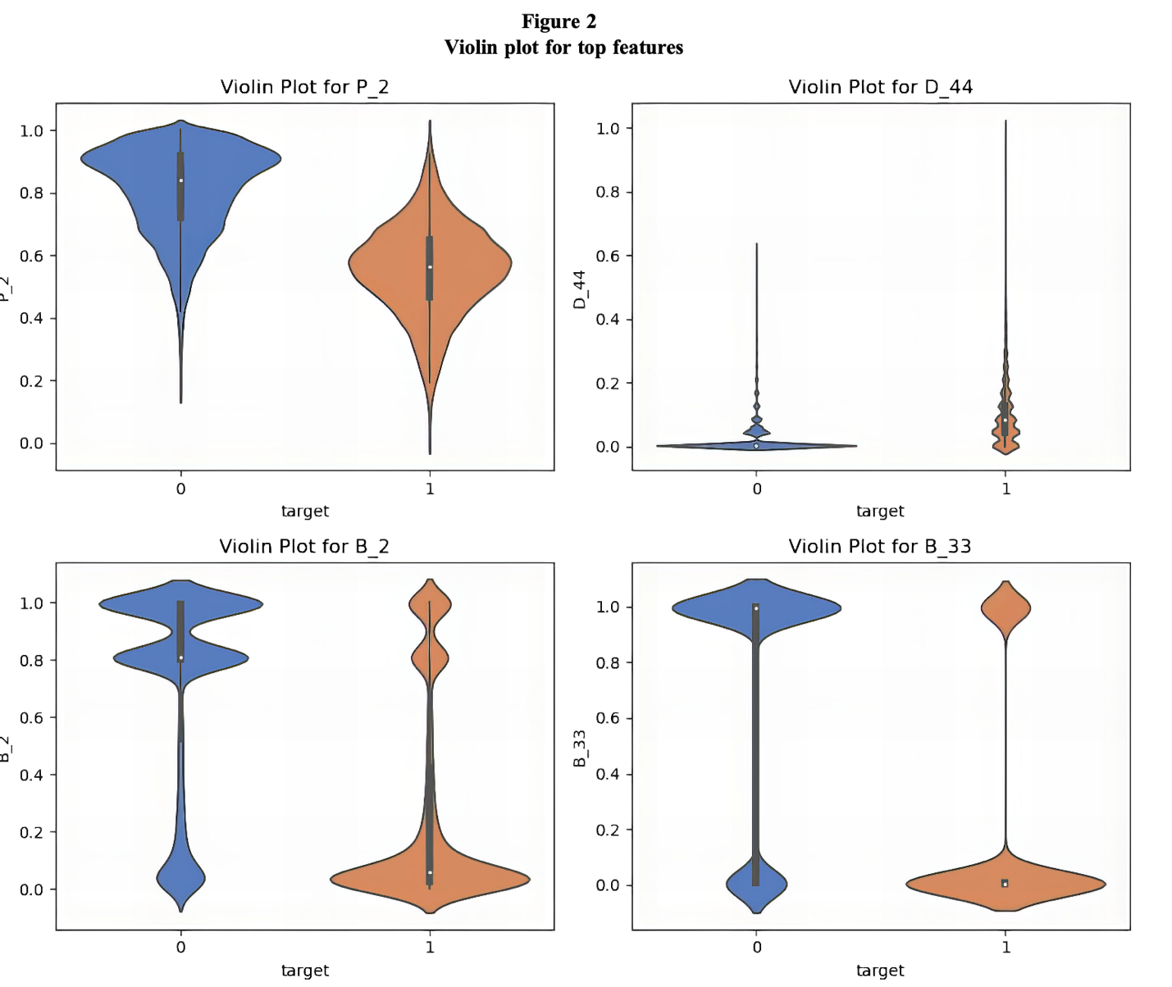

The author acknowledges tight distribution in D_44 and B_33 point to potential data imbalance. They believe the broader spread of P_2 in category 0 versus the broader spread in category 1 indicate non-linear relationships. This is important because it led to their doubt that a simple linear model would be adequate. Feature selection led to 47 of the 191 being used for modeling. The metrics used for scoring were the traditional accuracy, precision, recall, F-1 score, AP Score, and AUC. These metrics were chosen as they best explained the power of the model using multifaceted scoring metrics so one model doesn’t skew its results
Model selection was conducted only during the final evaluation, enabling the authors to demonstrate the distinctions and capabilities of various models. Throughout their report, the authors differentiate between hybrid and traditional models. While “out-of-the-box” traditional models exhibited satisfactory performance, their hybrid model significantly outperformed traditional models, thereby substantiating their assertions that the dataset comprises non-linear, intricate relationships that cannot be fully captured by traditional models. The hybrid model is designated as the Hybrid CNN-LSTM-Attention Framework. This hybrid model demonstrated the ability to discern robust patterns over time and frame-by-frame patterns, thereby acquiring a comprehensive understanding of the sequence and trend.
In similar fashion, before and after results for each type of model were recorded for hyperparameter turning. The author notes that some models responded different, with logistic regression showing a flat 0.0% difference across all scoring metrics. Neural Network’s Precision fell by 1.7% but its recall increased by 2.0%. After XGBoost was determined to be the highest scoring traditional model, it was used as the baseline for comparing against the hybrid model.

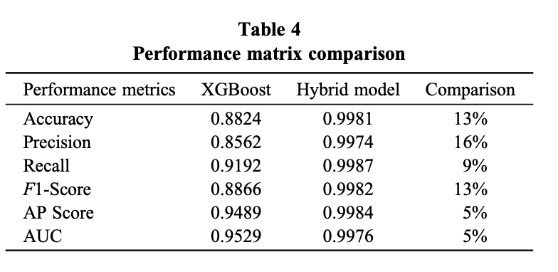

Conclusion

The hybrid model was shown to have the highest scores across all scoring metrics and was thus the best model for the task. As this research was conducted in a research-oriented fashion, the model itself was not deployed for real life use. Despite the superior results, the hybrid model suffers from a major drawback: computational resources. CNN and LSTM require computationally expensive operations to uncover their complex patterns, and the scalability meant the model would struggle in a real time environment with millions of customers.
By incorporating temporal data, the hybrid model proved itself to be the best model. The model predicted fraud with 99% accuracy. Such a model would bring economic stability by flagging future credit defaults. The model could also uncover more financial patterns that financial experts could leverage for risk. If resources or the model could be scaled to require lower computational costs, the model would be an excellent candidate for transforming the world of financial stability by providing an almost perfect prediction of credit card defaults. In the future, the team should have found a less computationally expensive model to deploy and evaluated the performance to verify real-time data with the evaluation metrics.

Works Cited
- “American Express - Default Prediction.” @Kaggle, 2025, www.kaggle.com/competitions/amex-default-prediction. Accessed 12 Oct. 2025.

